

**Sportz Magazine Statement of Work**



**Project Name:** Sportz Magazine

**Focus Area:** Requirements gathering/identification, analysis, use cases, documentation - general project management processes

**Product/Process:** Online subscription renewal application



**Prepared By**

|  |  |
| --- | --- |
| **Document Owner(s)** | **Project/Organization Role** (Put actual roles here) |
| Shaun Carter | Chief Visionary Officer |
| Chelsea Grindstaff | Director of Space & Time |
| Ronnie Goodrich | Chief Thought Provoker |
| Scottie Godfrey | VP of BS (Believable Solutions) |
| David Hodge | Abnormal Situation Manager |

**Project Charter Version Control**

|  |  |  |  |
| --- | --- | --- | --- |
| **Version** | **Date** | **Author** | **Change Description** |
| 1.0 | 10/03/13 | David Hodge | Charter created. |
| 1.1 | 10/16/13 | David Hodge | * Edited charter to reflect hand-out terminology |
| 1.2 | 10/21/13 | Chelsea Grindstaff | * Added context diagram |
| 1.3 | 10/22/13 | Shaun Carter | * Added use case diagram |
| 1.4 | 10/22/13 | David Hodge | * Added detailed use cases. |

**TABLE OF CONTENTS**

1 CHARTER PURPOSE 3

2 PROJECT EXECUTIVE SUMMARY 3

3 Enterprise Description/proposal Statement 3

4 PROJECT SCOPE 4

4.1 Goals and Objectives 4

4.2 Candidate Requirements 4

4.3 Schedule/Plan of Attack 5

4.4 Business Rules 5,6

4.5 Owners View 6

5 Domain analysis 7

5.1 Domain Scope 7

5.2 Domain Dictionary 7

5.3 Context Diagram 7

5.4 Use Case Diagram 8

5.5 Use Case Summary 8-9

5.6 Use-Cases 9-20

5.7 Class Diagram 21

5.8 Sequence Diagram 21

5.9 Activity Diagram 21

6 APPENDICES 22

6.2 Gantt Chart…………………………………………………………………………………22

6.3 Data Dictionary 22

# PROJECT CHARTER PURPOSE

The project charter defines the scope, objectives, and overall approach for the work to be completed. It is a critical element for initiating, planning, executing, controlling, and assessing the project. It should be the single point of reference on the project for project goals and objectives, scope, organization, and work plan. In addition, it serves as a contract between the Project Team members, stating what will be delivered by whom and during a specified timeframe. As they say, this is a living document so team members are encouraged to modify/add to the charter as circumstances dictate.



# PROJECT EXECUTIVE SUMMARY

The project team has tasked itself with the mock-creation of an online subscription renewal platform for Sportz Magazine. Users of the application should be able to establish/renew subscriptions to the magazine. The application must meet but are is limited to the following requirements for contributors and first-time subscribers:

* Maintain the name, the address, and the contact detail for each contributor.
* Maintain the details for each contribution, including the type of the contribution, the dates, the payments, and the complimentary subscription type.
* Record which staff is working with which contributor.
* Track the status of each contribution.
* Account for corporate and individual subscriptions
* Offer a money-back guarantee for first-time subscribers who want to cancel.
* Provide a free six-month extension to anybody who pays for three full years.



# ENTERPRISE DESCRIPTION/PROPOSAL

Sportz Magazine is a quarterly-published magazine that provides a summary of the sports news for the preceding quarter. In addition, the magazine seeks to enrich content through commentaries by well-known and respected sports writers, detailed interviews with athletes, health and nutrition information provided by sports physicians, and reviews of the latest athletic products from wardrobes to equipment.

The magazine seeks to combat its competition by revamping their web site while maintaining focus on the core business. The project team proposes to develop and document the processes that would be required to create an online subscription renewal platform for Sportz which is capable of maintaining the name, address and contact details for each contributor, maintaining the details for each contribution including type, date, payment and subscription type, record which staff is working with which contributor aand tracking the status of each contribution. The team will not actually implement any of the solutions, whoever it will establish and document each step in the problem solving process from requirements gathering to analysis and design – only stopping at implementation.



# PROJECT SCOPE

## Goals and Objectives

|  |
| --- |
| **Objectives** |
| 1. Define/document project scope    1. Identify top-level requirements (requirements discovery)    2. Identify factors/systems that will be affected by the project    3. Identify potential sources/domain experts    4. Identify potential constraints    5. Conduct feasibility study 2. Gather/document detailed requirements from requirements discovery    1. Establish business rules    2. Establish time-line for milestones/deliverables (Gantt chart)    3. Delegate tasks from above based upon team member strengths 3. Conduct domain analysis 4. Establish/document use cases 5. Establish structural modeling 6. Establish dynamic modeling |

## Candidate Requirements

|  |  |
| --- | --- |
| **Area of Focus** | **Deliverable(s)** |
| 1. Contributors | * Identify contributor type * Store information (contact) for new contributors * Manage information for existing contributors * Establish integrity of contributor * Assign staff partner for contributor * Track contributor progress |
| 1. Accounting | * Establish discounts based on subscriber type * Ensure secure/valid payment processing |
| 1. Logistics | * Verify that magazine is sent to subscribers * Track delivery * Mitigate shipping problems |
| 1. Subscriptions | * Store info for new subscribers * Identify type of subscriber (consumer/corporate) * Store info for existing subs * Track promotions for subscription types * Renew subscriptions |
| 1. Marketing | * Create promotions for subscriptions * Create subscription forms * Establish a web presence/platform for potential subscribers |

## Schedule/Plan of Attack

|  |  |  |  |  |  |
| --- | --- | --- | --- | --- | --- |
| Task Name | Duration | Start | Finish | Predecessors | Resource Names |
| **ScopeDefinition** | **5.5 days?** | **Thu 10/3/13** | **Thu 10/10/13** |  |  |
| Determine project scope | 4 hrs | Thu 10/3/13 | Thu 10/3/13 |  | Team |
| Create Gantt chart | 1 day | Thu 10/3/13 | Fri 10/4/13 | 2 | Team |
| Create summary and primitive tasks | 1 day | Fri 10/4/13 | Mon 10/7/13 | 3 | Team |
| Document owner's view | 1 day | Mon 10/7/13 | Tue 10/8/13 | 4 | Team |
| Establish candidate requirements | 0 days | Tue 10/8/13 | Tue 10/8/13 | 5 | Team |
| Document statement of work | 1 day? | Tue 10/8/13 | Wed 10/9/13 | 6 | Team |
| Scope complete | 1 day? | Wed 10/9/13 | Thu 10/10/13 | 7 | Team |
| **Domain Analysis** | **16 days?** | **Thu 10/10/13** | **Fri 11/1/13** |  |  |
| Determine domain scope | 5 days | Thu 10/10/13 | Thu 10/17/13 | 8 | David |
| Document domain dictionary | 3 days | Thu 10/17/13 | Tue 10/22/13 | 10 | Scottie |
| Create context diagram | 2 days | Tue 10/22/13 | Thu 10/24/13 | 11 | Chelsea |
| Develop use case diagram | 8 hrs | Thu 10/24/13 | Fri 10/25/13 | 12 | Shaun |
| Develop use case summary | 0.5 days | Fri 10/25/13 | Fri 10/25/13 | 13 | Ronnie,Shaun |
| Develop use cases | 1 day | Mon 10/28/13 | Mon 10/28/13 | 14 | Ronnie |
| Create class diagram | 1 day? | Tue 10/29/13 | Wed 10/30/13 | 15 | David |
| Establish sequence diagram | 1 day? | Wed 10/30/13 | Thu 10/31/13 | 16 | Someone |
| Establish activity diagram | 1 day? | Thu 10/31/13 | Fri 11/1/13 | 17 | Someone |
| Analysis complete | 0 days | Fri 11/1/13 | Fri 11/1/13 | 18 | Team |
| **Design** | **4 days** | **Fri 11/1/13** | **Wed 11/6/13** |  |  |
| Design complete | 3 days | Mon 11/4/13 | Wed 11/6/13 |  |  |

## Business Rules

* Individuals
  + Subscriptions based on single-copy orders
  + Delivered to the individual’s address directly
* Corporations
  + Subscriptions based on multiple-copy orders
  + Corporations receive 5% – 10% discount on orders
  + Delivered to designated unit heads
* Athletes
  + Not paid for contributions
  + Receive one-year subscription for one interview per year
  + Each extra interview means an additional one-year subscription
    - Should try to limit athletes to two interviews per year
* Writers
  + Receive one-year subscription for two contributions per year
* Domain Experts
  + Receive a one-year subscription for one article per year

## Owner’s View

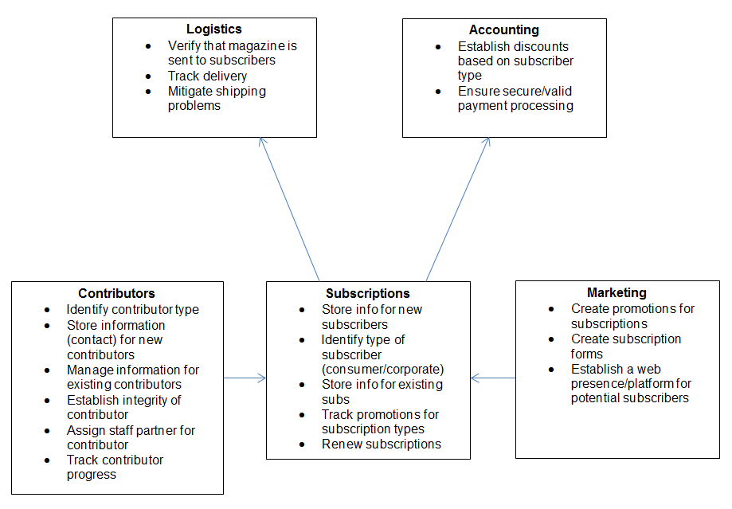



# Domain Analysis

## Domain Scope

* Subscriptions
  + Subscription application
  + Subscription approval
  + Subscription renewal for user
  + Evaluate/update subscription type (corporate/consumer/contributor)
  + Issue discount based upon user type
* Contributors
  + Store contributor contact/info
  + Manage collaboration between contributor and staff
  + Track contribution status
  + Record previous contributions
  + Contribution approval system
* Accounting
  + Track user payment information
  + Work with bank to validate credit card
  + Work with bank to charge card
  + Establish system for corporate users

## Domain Dictionary

## Context Diagram

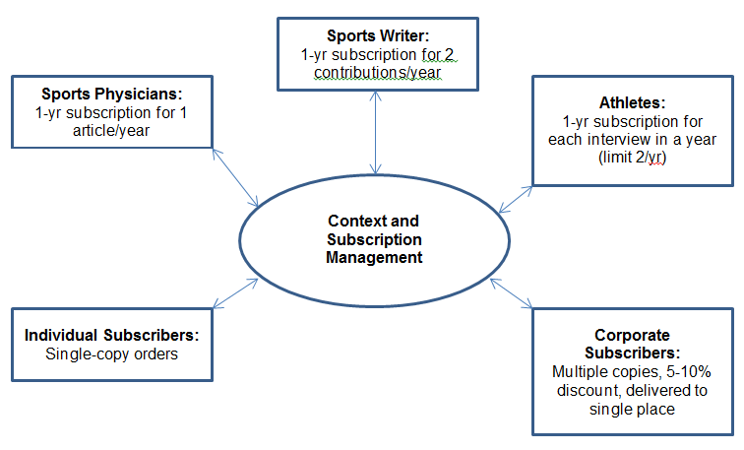

## Use Case Diagram

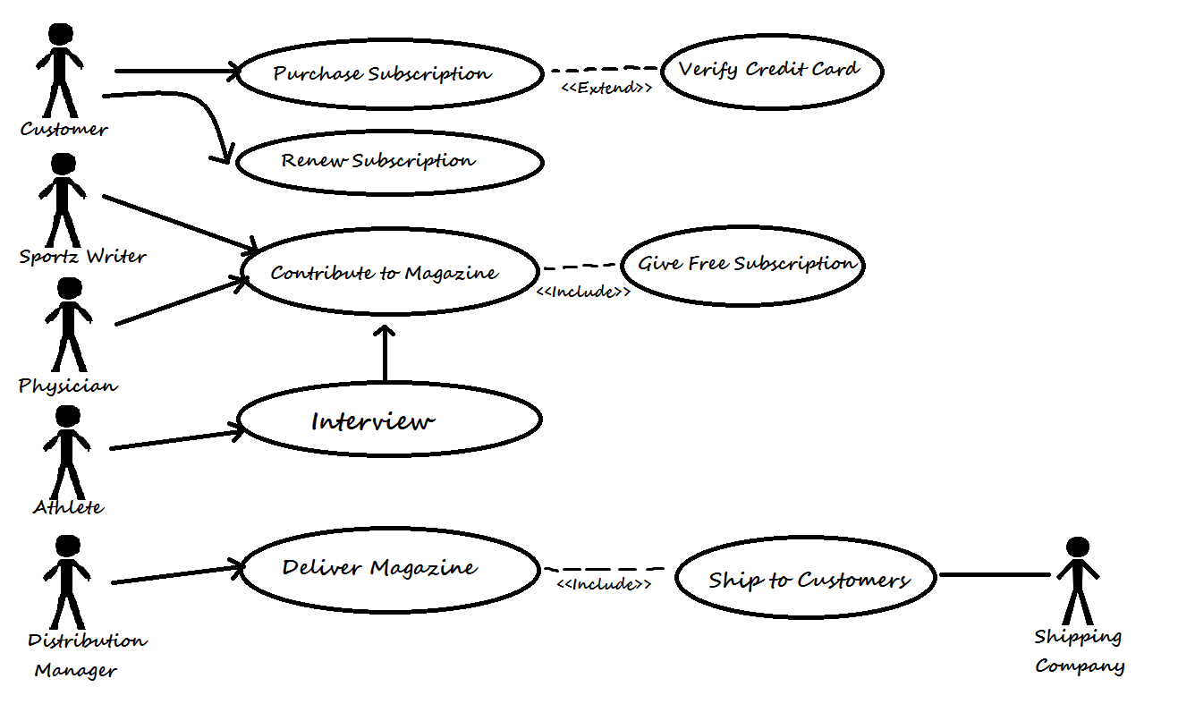

## Use Case Summary

|  |  |  |  |
| --- | --- | --- | --- |
| **Sportz Magzine – Subscription Management Use Case Summary** | | | |
| **ID** | **Name** | **Description** | **Actors** |
| 000 | Apply to Subscribe | Applicant browses to online subscription application, chooses the type of subscription, enters contact and payment information and submits the application. | * Applicant |
| 005 | Approve Subscription | Subscription Staff verifies new Applicant account, that the application is successfully filled out and that payment is valid. Subscription Staff approves subscription and Applicant is notified. | * Subscription Staff * Payment System |
| 010 | Complete Subscription | Subscription Staff applies any promotions/discounts and calculates final fee to payment system. Subscription staff adds new subscriber to database. | * Subscription Staff * Payment System |
| 015 | Give Free Subscription | After approval, contributors receive free subscription. | * Subscription Staff |
| 020 | Renew Subscription | If a subscription is ending, notify subscriber to renew. | * Subscriber * Information System |
| 025 | Verify Credit Card | Subscription staff sends payment information to bank/payment system and the system validates said information. | * Subscription Staff * Payment System |
| 030 | Charge Credit Card | Subscription staff calculates final fee and sends to the payment system to charge the credit card. | * Subscription System * Payment System |
| 035 | Get Contributions | Contributions are one of the main source of articles for the magazine. The magazine’s Collaborator works with the Contributor to track all of the Contributor’s information. The Contributor needs to be able to track his/her information online with the new system. | * Collaborator |
| 040 | Conduct Interview | The process by which an Athelete interviews with the magazine writers to produce an article. The athelete’s interview is recorded in the system so that the interview can be contributed for the magazine and the athlete reimbursed via a free subscription to the magazine. | * Contributor * Collaborator |
| 045 | Deliver Magazine (Corporate) | Customers with multiple subscriptions have magazine sent to a unit head who finishes the distribution | * Distribution   Manager   * Shipping Company |
| 050 | Deliver Magazine (Individual) | Preparation of magazine to be shipped to residential customer. | * Distribution Manager * Shipping Company |
| 055 | Ship to Customer | Magazine placed in care, custody and control of shipping company | * Distribution Manager * Shipping Company * Customer |

## Use-Cases

|  |  |
| --- | --- |
| Use Case: | Apply to Subscribe |
| ID: | 000 |
| Scope: | Subscription Management |
| Priority: | 1/5 |
| Summary: | Applicant browses to online subscription application, chooses the type of subscription, enters contact and payment information and submits the application. |
| Primary Actor: | Applicant |
| Supporting Actors: |  |
| Stakeholders: | * Magazine – Wants that cash. Must deliver subscription. |
| Generalization: |  |
| Include: |  |
| Extend: |  |
| Precondition: | Applicant is a new subscriber. |
| Trigger: |  |
| Normal Flow: | 1. Applicant browses to online subscription application. 2. Applicant chooses the type of subscription – can be individual or corporate. 3. Applicant enters contact information. 4. Applicant enters payment information. 5. Applicant submits application. |
| Sub Flows: | **4.1.** Applicant enters name  **4.2.** Applicant enters address  **4.3.** Applicant enters phone number  **4.4.** Applicant enters email |
| Alternate Flow/ Exceptions: | 2.a. If Applicant is corporate, enter the number of copies. |
| Post-Condition: | Application submits and is ready for review by Subscription Staff. |
| Open Issues: |  |
| Source: |  |
| Author: | David Hodge |
| Revision & Date: | 1.0 10/22/2013 |

|  |  |
| --- | --- |
| Use Case: | Approve Subscription |
| ID: | 005 |
| Scope: | Subscription Management |
| Priority: | 1/5 |
| Summary: | Subscription Staff verifies new Applicant account, that the application is successfully filled out and that payment is valid. Subscription Staff approves subscription and Applicant is notified. |
| Primary Actor: | Subscription Staff |
| Supporting Actors: | * Bank/Payment Service |
| Stakeholders: | * Magazine – Got that cash. Must deliver magazines. * Applicant – Wants a subscription. |
| Generalization: |  |
| Include: | 025: Verify Credit Card. |
| Extend: |  |
| Precondition: | System receives the new application. |
| Trigger: | System informs Subscription Staff that there is a new application waiting to be approved. |
| Normal Flow: | 1. Subscription staff verifies that the account is new. 2. Subscription staff verifies application information. 3. Subscription staff verifies payment.   (**Include** 025: Verify Credit Card)   1. Subscription staff approves the application. 2. Applicant is notified by subscription staff. |
| Sub Flows: |  |
| Alternate Flow/ Exceptions: | 1.a. Not a new account. Reject application, tell Applicant.  **3.a.** Invalid payment. Reject application, tell Applicant. |
| Post-Condition: | Subscription staff approves new subscription. |
| Open Issues: |  |
| Source: |  |
| Author: | David Hodge |
| Revision & Date: | 1.0 10/22/2013 |

|  |  |
| --- | --- |
| Use Case: | Complete Subscription |
| ID: | 010 |
| Scope: | Subscription Management |
| Priority: | 3/5 |
| Summary: | Subscription Staff applies any promotions/discounts and calculates final fee to payment system. Subscription staff adds new subscriber to database. |
| Primary Actor: | Subscription Staff |
| Supporting Actors: | * Bank/Payment Service |
| Stakeholders: | * Magazine – Got that cash. Must deliver magazines. * Applicant – Wants a subscription. |
| Generalization: |  |
| Include: | 030: Charge Credit Card. |
| Extend: |  |
| Precondition: | Application is approved. |
| Trigger: |  |
| Normal Flow: | 1. Subscription Staff applies discount(s). 2. Subscription Staff calculates final fee. 3. Subscription Staff sends fee to payment system.   (**Include 030:** Charge Credit Card)   1. Subscription Staff adds new subscriber to database. |
| Sub Flows: |  |
| Alternate Flow/ Exceptions: |  |
| Post-Condition: | New subscription complete, added to database. |
| Open Issues: |  |
| Source: |  |
| Author: | David Hodge |
| Revision & Date: | 1.0 10/22/2013 |

|  |  |
| --- | --- |
| Use Case: | Give Free Subscription |
| ID: | 015 |
| Scope: | Subscription Management |
| Priority: | 2/5 |
| Summary: | After approval, contributors receive free subscription. |
| Primary Actor: | Subscription Staff |
| Supporting Actors: |  |
| Stakeholders: | * Contributor – entitled to free subscription * Magazine – responsible for magazine delivery |
| Generalization: |  |
| Include: |  |
| Extend: |  |
| Precondition: | Contributor must create a contribution. |
| Trigger: |  |
| Normal Flow: | 1. Staff reviews Contributor’s contributions 2. Staff creates new account for Contributor 3. Staff approves Contributor’s free subscription.    1. Physician must contribute at least one article per year    2. Athlete – one interview per year    3. Writer – two articles per year 4. Contributor receives subscription. |
| Sub Flows: |  |
| Alternate Flow/ Exceptions: | 2.a. Previous Contributor already has account. Existing subscription is extended. |
| Post-Condition: | Contributor receives free subscription. |
| Open Issues: |  |
| Source: | * Source of information for this use case |
| Author: | Ronnie Goodrich |
| Revision & Date: | 1.0 10/22/2013 |

|  |  |
| --- | --- |
| Use Case: | Renew Subscription |
| ID: | 020 |
| Scope: | Subscription Management |
| Priority: | 3/5 |
| Summary: | If a subscription is ending, notify subscriber to renew. |
| Primary Actor: | Subscriber |
| Supporting Actors: | * Information System |
| Stakeholders: | * Subscriber – wants to keep subscription * Magazine – wants that continued cash. |
| Generalization: |  |
| Include: |  |
| Extend: |  |
| Precondition: |  |
| Trigger: | Subscription is about to expire. |
| Normal Flow: | 1. System tells user of upcoming subscription expiration. 2. Subscriber browses to subscription renewal page. 3. Subscriber chooses renewed subscription type. 4. Subscriber enters payment information. 5. Subscriber submits renewal. 6. System confirms renewal. |
| Sub Flows: |  |
| Alternate Flow/ Exceptions: |  |
| Post-Condition: | Renewal is submitted. |
| Open Issues: |  |
| Source: |  |
| Author: | David Hodge |
| Revision & Date: | 1.0 10/22/2013 |

|  |  |
| --- | --- |
| Use Case: | Verify Credit Card |
| ID: | 025 |
| Scope: | Subscription Management |
| Priority: | 3/5 |
| Summary: | Subscription staff sends payment information to bank/payment system and the system validates said information. |
| Primary Actor: | Subscription Staff |
| Supporting Actors: | * Payment System |
| Stakeholders: | * Applicant – wants to create subscription. * Magazine – wants that continued cash. * Subscription Staff – needs to know how to proceed with application. |
| Generalization: |  |
| Include: |  |
| Extend: |  |
| Precondition: |  |
| Trigger: | Subscription Staff sends request to payment system. |
| Normal Flow: | 1. Subscription Staffs sends payment info from application to payment system. 2. Payment system validates payment information. 3. Payment system sends approval to Subscription Staff. |
| Sub Flows: |  |
| Alternate Flow/ Exceptions: | **2.a.** Payment information is not valid.  **3.a.** Payment system sends rejection to Subscription Staff. |
| Post-Condition: | Payment is verified. |
| Open Issues: |  |
| Source: |  |
| Author: | David Hodge |
| Revision & Date: | 1.0 10/22/2013 |

|  |  |
| --- | --- |
| Use Case: | Charge Credit Card |
| ID: | 030 |
| Scope: | Subscription Management |
| Priority: | 2/5 |
| Summary: | Subscription staff calculates final fee and sends to the payment system to charge the credit card. |
| Primary Actor: | Subscription Staff |
| Supporting Actors: | * Payment System – facilitates payment. |
| Stakeholders: | * Applicant – wants to create subscription. * Magazine – wants that continued cash. |
| Generalization: |  |
| Include: |  |
| Extend: |  |
| Precondition: | Payment information is validated and subscription application is approved. |
| Trigger: | Subscription Staff sends fee to payment system. |
| Normal Flow: | 1. Subscription Staff calculates final fee 2. Subscription Staff sends final fee to payment system 3. Payment system charges fee to subscribers credit card |
| Sub Flows: |  |
| Alternate Flow/ Exceptions: |  |
| Post-Condition: | Payment is processed. |
| Open Issues: |  |
| Source: |  |
| Author: | David Hodge |
| Revision & Date: | 1.0 10/22/2013 |

|  |  |
| --- | --- |
| Use Case: | GET CONTRIBUTIONS FOR MAGAZINE |
| ID: | 035 |
| Scope: | Subscription Management |
| Priority: | 4/5 |
| Summary: | Contributions are one of the main source of articles for the magazine. The magazine’s Collaborator works with the Contributor to track all of the Contributor’s information. The Contributor needs to be able to track his/her information online with the new system. |
| Primary Actor: | Collaborator |
| Supporting Actors: |  |
| Stakeholders: | * Contributors – Provide contributions for magazine. |
| Generalization: |  |
| Include: | * 040: Give Free Subscription |
| Extend: |  |
| Precondition: | The collaborator has verified that the contributor has been contacted and has agreed to write an article. |
| Trigger: | The collaborator is informed that the date and subject matter of the article has been determined. |
| Normal Flow: | 1. Collaborator receives contribution from contributor.  2. Collaborator enters or updates the contact information for the contributor.  3. Collaborator enters contribution details. (Include: 040: Give Free Subscription.)  4. Collaborator records which editor is working with the contributor.  5. Collaborator tracks the status of the contribution. |
| Sub Flows: | 2.1 Collaborator enters contributor’s name.  2.2 Collaborator enters contributor’s address.  2.3 Collaborator enters contributor’s contact number.  3.1 Collaborator enters contribution type.  3.2 Collaborator enters contribution dates.  3.3 Collaborator enters contribution payments.  3.4 Collaborator enters contribution complimentary subscription type details. (Include: 040: Give Free Subscription.) |
| Alternate Flow/ Exceptions: |  |
| Post-Condition: | The contributor can verify his/her contribution information on the new system website. |
| Open Issues: | I.1 If a sports physician writes more than one article per year, how many additional one-year subscriptions to the magazine can he/she receive?  I.2 If a sports writer writes more than two articles per year, how many additional one-year subscriptions to the magazine can he/she receive? |
| Source: |  |
| Author: | Chelsea Grindstaff |
| Revision & Date: | 1.0 10/22/2013 |

|  |  |
| --- | --- |
| Use Case: | Conduct Interview |
| ID: | 040 |
| Scope: | Contributions to magazine |
| Priority: | Subscription Management |
| Summary: | The process by which an Athelete interviews with the magazine writers to produce an article. The athelete’s interview is recorded in the system so that the interview can be contributed for the magazine and the athlete reimbursed via a free subscription to the magazine. |
| Primary Actor: | Contributor |
| Supporting Actors: | Collaborator |
| Stakeholders: | * Customer (reads the interview) * Writer (records the interview and writes the article) * Athlete (receives subscription based on contribution) |
| Generalization: | Contribution |
| Include: | * Contribute * Give Free Subscription |
| Extend: |  |
| Precondition: |  |
| Trigger: | Athlete agrees to give interview. |
| Normal Flow: | 1. Writer asks to interview athlete 2. Sportz Management grants writer permission to interview. 3. Writer Interviews athlete. 4. Interview is contributed to magazine. 5. Athlete gets 1 year free subscription. 6. It is recorded that they have been interview once this year. |
| Sub Flows: | 2.1 Management checks to see if the athlete has been interviewed before.  2.2 Management can grant interview if athlete has not been interviewed before. |
| Alternate Flow/ Exceptions: | 2.a Management can grant exception to preference in rare cases.  3.a Writer does not interview. |
| Post-Condition: | Interview must be Contributed to magazine. |
| Open Issues: |  |
| Source: |  |
| Author: | Shaun Carter |
| Revision & Date: | 1.0 10/22/2013 |

|  |  |
| --- | --- |
| Use Case: | Deliver Magazine- Corporate Subscribers |
| ID: | 045 |
| Scope: | Distribution |
| Priority: | 4/5 |
| Summary: | Customers with multiple subscriptions have magazine sent to a unit head who finishes the distribution |
| Primary Actor: | Distribution Manager |
| Supporting Actors: | Shipping company |
| Stakeholders: | * Distribution Manager |
| Generalization: |  |
| Include: | * Ship to Customer |
| Extend: |  |
| Precondition: | Payment of subscription, multiple subscriptions |
| Trigger: | Quarterly cycle |
| Normal Flow: | 1. Send magazine to unit head  2. Unit head distributes magazines throughout company |
| Sub Flows: |  |
| Alternate Flow/ Exceptions: | 1.a Additional subscriptions/cancellation of subscriptions |
| Post-Condition: | Magazines are distributed to corporate customer’s unit head |
| Open Issues: | I.1 Change in unit head, how to reroute to new unit head. |
| Source: | * Sportz Magazine charter |
| Author: | Scottie Godfrey |
| Revision & Date: | 1.0 11/5/2013 |

|  |  |
| --- | --- |
| Use Case: | Deliver Magazine- Individual Subscribers |
| ID: | 050 |
| Scope: | Distribution |
| Priority: | 4/5 |
| Summary: | Preparation of magazine to be shipped to residential customer. |
| Primary Actor: | Distribution manager |
| Supporting Actors: | Shipping company |
| Stakeholders: | * Distribution Manager |
| Generalization: |  |
| Include: | * Ship to Customer |
| Extend: |  |
| Precondition: | Payment of subscription |
| Trigger: | Quarterly cycle |
| Normal Flow: | 1. Send magazine to shipping company for delivery  2. Shipping Company delivers magazine to customer |
| Sub Flows: |  |
| Alternate Flow/ Exceptions: | 1.a If customer cancels subscription, make sure magazine does not go to shipping company for that customer |
| Post-Condition: | Magazine is delivered to customer |
| Open Issues: | I.1 Which shipping company is cheapest and most reliable? |
| Source: | * Sportz Magazine charter |
| Author: | Scottie Godfrey |
| Revision & Date: | 1.0 11/5/2013 |

|  |  |
| --- | --- |
| Use Case: | Ship to Customer |
| ID: | 055 |
| Scope: | Distribution |
| Priority: | Priority on scale (i.e., 1/5, 2/5, 5/5) |
| Summary: | Magazine placed in care, custody and control of shipping company |
| Primary Actor: | Distribution manager |
| Supporting Actors: | Shipping company, customer |
| Stakeholders: | * Distribution Manager |
| Generalization: |  |
| Include: |  |
| Extend: |  |
| Precondition: | Distribution manager approval |
| Trigger: | Quarterly cycle |
| Normal Flow: | 1. shipping company sends magazine to last known address  2. customer receives magazine |
| Sub Flows: |  |
| Alternate Flow/ Exceptions: | 1.a return to sender, refuse delivery, cancel subscription |
| Post-Condition: | Customer takes care, custody and control of magazine |
| Open Issues: | I.1 Which shipping company is cheapest and most reliable? What service levels are needed to insure magazine is not damaged in route to customer. |
| Source: | * Sportz Magazine charter |
| Author: | Scottie Godfrey |
| Revision & Date: | 1.0 11/5/2013 |

## Class Diagram

|  |  |  |
| --- | --- | --- |
| **Class** | **Responsibilities** | **Use Cases** |
| Contributor | * Contributor ID * Contributor name * Contributor phone * Contributor address * Contributor email | * 035 |
| Contributions | * Date of contribution * Title of contribution * Contribution frequency * Contributor ID | * 035 |
| Subscriber | * Subscriber ID * Subscriber name * Subscriber phone/address/email * Send renewal message | * 000 |
| Payment | * Type * Amount * Apply discount * Calculate total | * 010 * 030 |
| Credit | * Card ID * Card number * Cardholder name * Bank * Validation * Charge | * 025 * 030 |
| Subscription | * Sub type * Sub length * Mailing address * Number of subscriptions | * 000 * 005 * 010 |

## Sequence Diagram

## Activity Diagram

# APPENDICES

## Gantt Chart

## Domain dictionary

## Forms/Reports

